SIMATS ENGINEERING (SAVEETHA SCHOOL OF ENGINEERING)
Department of Computer Science and Engineering

ASSESSMENT TOOL 2 – SCENARIO BASED ASSESSMENT
Course Code: | CSA0615 |  | Course Title: | Design and Analysis of Algorithms
CO Assessed: | CO2 – Manipulation (BL1, BL2, BL3) |  | Assessment: | Assessment Tool 2 – Scenario  Based Assessment
Weightage: | 20% of CIA |  | Total Marks: | 100
CO2 Statement: | Apply Brute Force technique to solve sorting, searching, Closest-Pair and Convex-Hull problems  (BL1, BL2, BL3)
Student Name: | Lella Thannveer Reddy |  | Reg. No.: | 192524293
Section / Batch: | Slot - A |  | Date: | 03/08/2026
Instructions to Students
- Answer BOTH scenario-based questions. Each question carries 50 Marks. Total: 100 Marks.
- Carefully analyze the given scenario and identify the computational problem involved.
- Apply appropriate Brute Force techniques for sorting, searching, Closest-Pair, and Convex-Hull problems wherever applicable.
- Clearly justify the chosen solution approach with proper reasoning and analytical interpretation.
- Demonstrate decision-making skills by comparing possible solutions and selecting the most suitable approach.
- Use diagrams, stepwise illustrations, or algorithmic representations wherever necessary.
- Maintain clarity, logical organization, and proper technical presentation throughout the answers.
Question Type |  | Focus Area |  |  | Questions Marks
Scenario Based Assessment |  | Analyze real-world scenarios and apply Brute Force techniques for sorting, searching, Closest-Pair, and Convex-Hull problems |  |  | Q1 - Q2 | 100 (2 × 50)
 |  | GRAND TOTAL: |  |  | 100 Marks
SECTION A – SCENARIO BASED ASSESSMENT

QUESTION-1
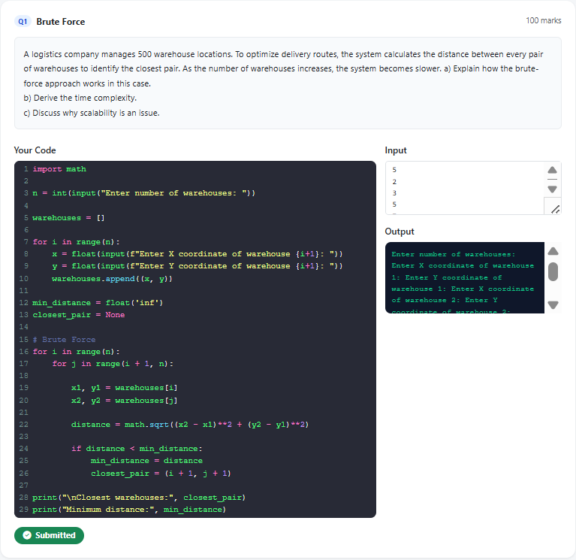

QUESTION-2
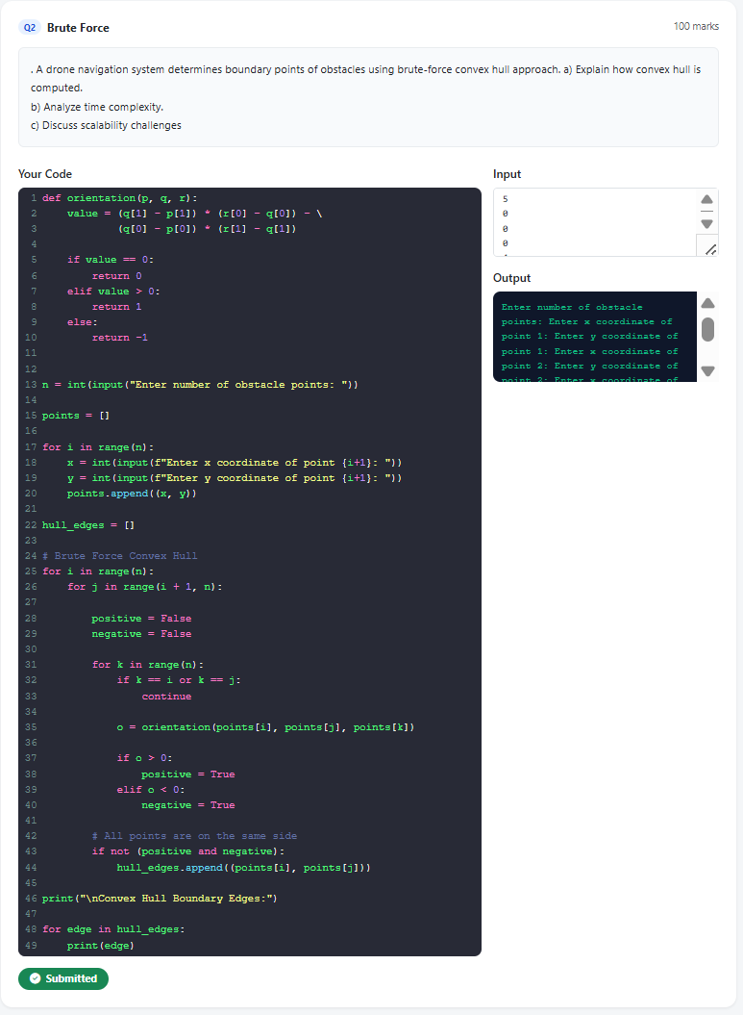
Code of Conduct
I _Lella Thannveer Reddy/192524293_(Name / Reg No) certify that this submission is my original work and that I have adhered to the guidelines specified for this assessment. I understand that any violation of academic integrity rules will result in disciplinary action.
Signature of the Student:

RUBRICS FOR CALCULATION
Level 3 – Level 2 – Level 1 –
Criteria Wt. Level 4 – Exemplary
Proficient Developing Beginning
Thoroughly Basic
Problem understands the Clearly understanding; Poor
Understanding scenario with accurate understands the some aspects of understanding or
& Context interpretation of all scenario with the scenario misinterpretation
Analysis 25 requirements minor gaps unclear of the scenario
Application of 30 Applies appropriate Applies relevant Applies basic Fails to apply
Concepts concepts effectively to concepts concepts but appropriate solve complex real- correctly with with limited concepts
 |  | world problems | minor errors | accuracy
Analytical &  DecisionMaking Skills | 20 |  |  |  | Poor or no analysis; incorrect decisions
Analytical &  DecisionMaking Skills | 20 | Demonstrates strong analysis and selects optimal solutions with justification | Good analysis with reasonable solutions | Limited analysis; solutions lack justification | Poor or no analysis; incorrect decisions
Solution Design & Approach | 15 | Well-structured, innovative, and  feasible solution approach | Logical and structured solution with minor gaps | Basic solution with limited structure or feasibility | Unclear or incorrect solution approach
Clarity,  Justification &  Presentation | 10 | Clear, well-justified explanation with strong reasoning | Clear explanation with some  justification | Limited clarity and weak  justification | Poorly explained with no justification
Marks Evaluation:
Question No. | Problem  Understanding &  Context Analysis (25%) | Application of Concepts  (30%) |  | Analytical &  Decision-  Making Skills (20%) | Solution  Design &  Approach  (15%) |  | Clarity,  Justification &  Presentation  (10%) | Total  Marks  (Each –  50)
Q1
Q2
 |  |  |  |  | Overall Total (100)
Faculty In-charge |  |  | Course Coordinator |  |  | Head of Department
Signature: _______________ |  |  | Signature: _______________ |  |  | Signature: _______________
Date: ___________________ |  |  | Date: ___________________ |  |  | Date: ___________________

